8.48: As in Example 8.15, the center of mass remains at rest, so there is zero net momentum, and the magnitudes of the speeds are related by 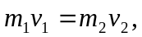 or

